|  |
| --- |
| **Running Javascript In The Browser** |

Let us create an HTML File and link a JS File to it.

|  |
| --- |
| <!DOCTYPE html>  <html lang="en">  <head>      <meta charset="UTF-8">      <meta name="viewport" content="width=device-width, initial-scale=1.0">      <title>Document</title>  </head>  <body>    *<!-- Script File -->*      <script src="script1.js"></script>  </body>  </html> |

Next we can add some code in the JS File and the load the HTML file using the VS Code Live server

|  |
| --- |
| alert("Hello"); |

Output

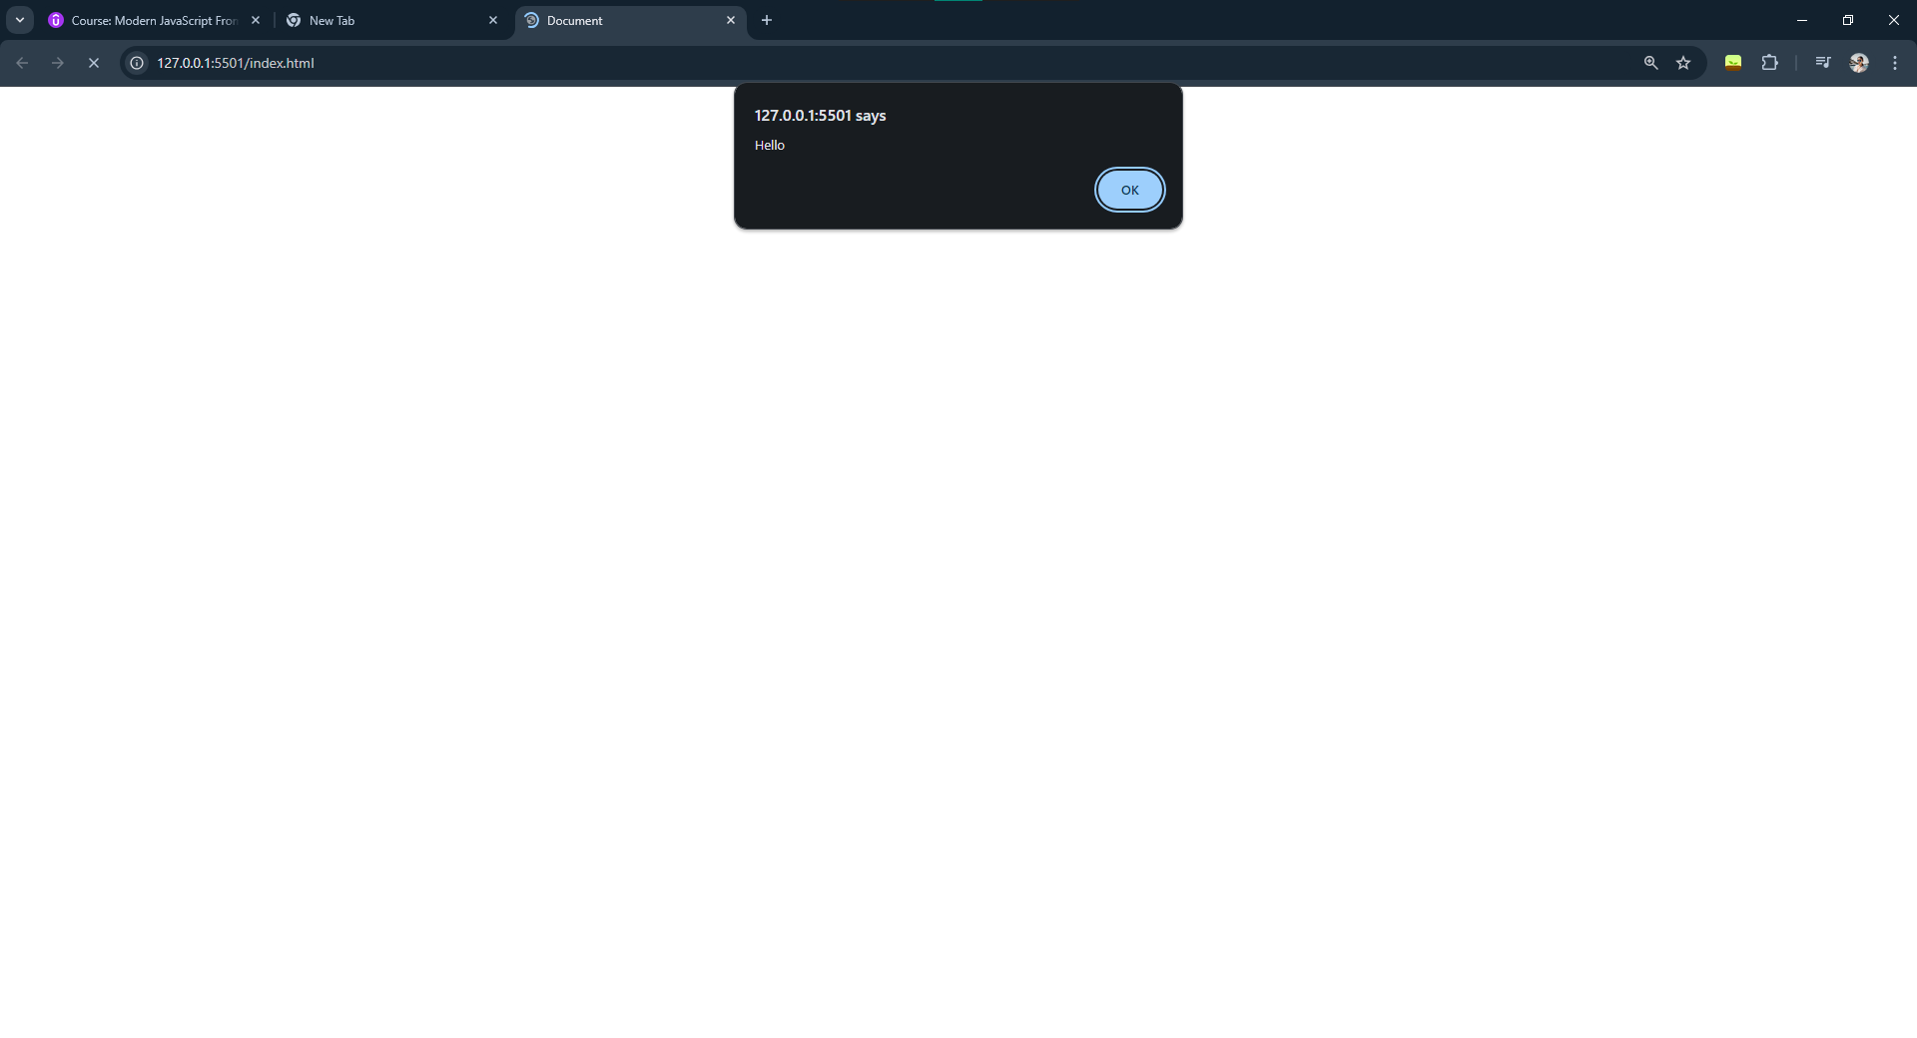

|  |
| --- |
| **Using The Console** |

* **Logging something to the console**

If we write the following code in the JS file

|  |
| --- |
| console.log("Hello World") |

Output

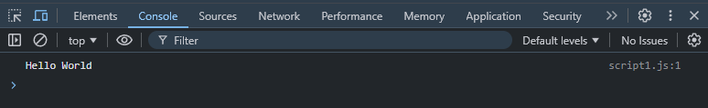

We can log more than one thing at the same time in the console

If we write the following code in the JS file.

|  |
| --- |
| console.log("Hello World", 100); |

Output

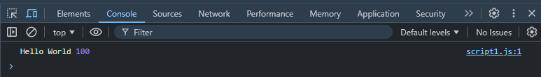

The colors of the items are different as they are different datatypes. The “Hello World” is a string and the 100 is a number

* **Logging Errors And Warnings In The Console**

If we write the following code in the JS file

|  |
| --- |
| console.error("This is an error message");  console.warn("This is a warning message"); |

Output

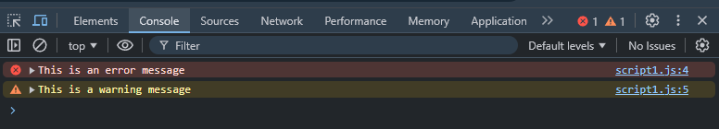

* **Logging Key Value Pairs In Console In Tables**

|  |
| --- |
| console.table({name:"Sagnik",profession:"Software Engineer"}) |

Output

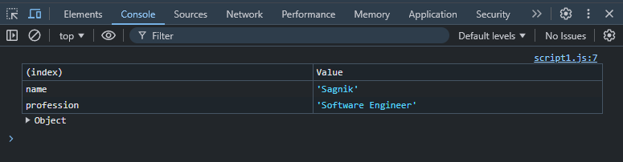

|  |
| --- |
| **Variables And Constants** |

Let us create an HTML File and link a JS File to it.

* Item 1
* Item 2
* Item 3